1. INTRODUCTION:
   1. OVERVIEW

Dream homes reality, construction company, uses zoho books to track project expenses, manage subcontractor payments and handle invoicing. They can generate estimates and invoices for client , track job costing, and monitor the profitability of each department. Zoho books provides them with financial insights to make informed decisions

2.1 purpose:

1. Zoho books one gives you accounting tools to categorisze transaction, tack cash flos, monitor your financial health. Keep your accounts organised to track your asets and liabilities. Connect your bank account to automatically import transactions
2. Zoho books is your one stop platform for managing your accounting task and organizing your transactions. It’s a single secure location to keep up with your companys bills and invoices, recocil your bank statement, control your spending, oversee projects, and eliminate GST compliance worries.

2.PROBLEM DEFINITION AND DESIGN THINKING:

2.1 EMPATHY MAP

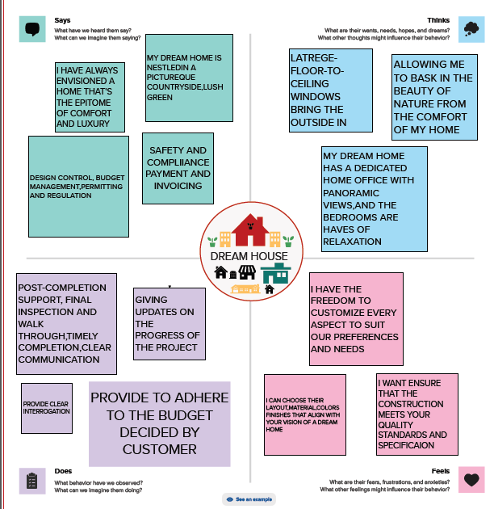

* 1. 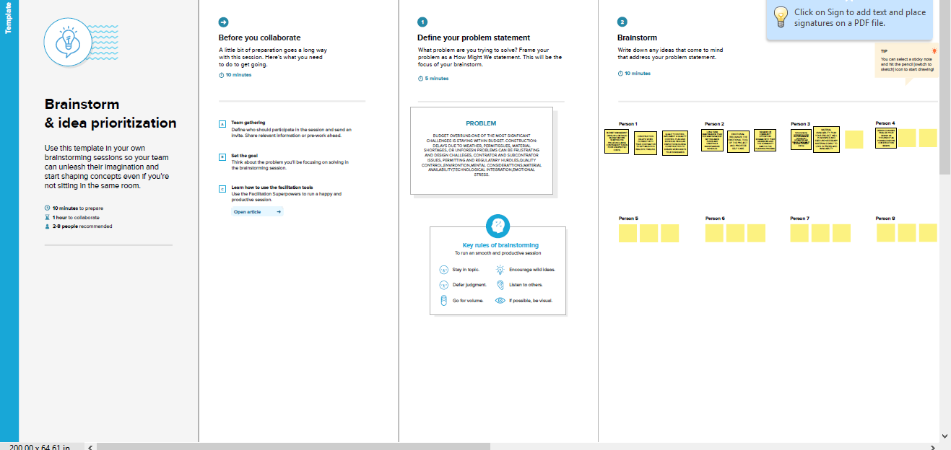IDEATION AND BRAINSTORMING MAP

3. RESULT:

OUTPUT:

The output of profit and loss for Vignesh zoho books company form 01/04/2023 to 30/03/2023 with the profit

Of Rs 7,48,00,000.00

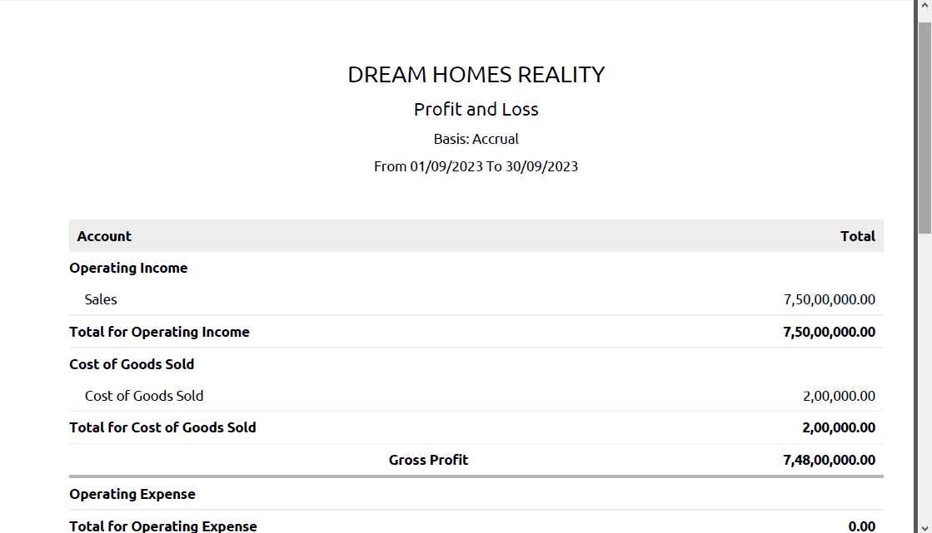

The balance sheet as on 08/05/2023 with the total assets and the total liabilities of Rs 8,73,45,000.00

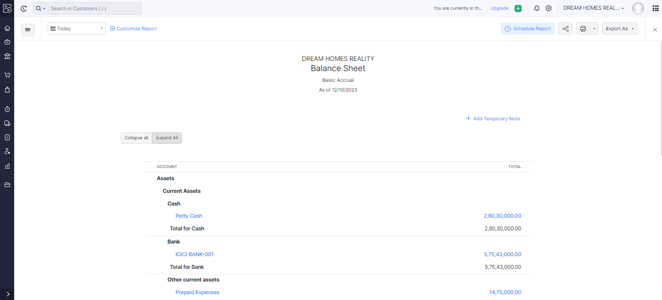

4. ADVANTAGES AND DISADVANTAGES:

ADVANTAGES

1. Manage different aspects of construction operation efficiently with easy acces to critical patient information.
2. Zoho books provides robust financial reporting capabilities, enabling business to generate carious reports, track income and expenses and gain insights into their financial perofrmence
3. Zoho books supports multiple currencies, making it suitable for business keep engaged in international trae or dealing eith clients in different countries
4. Zoho books provides customer support and resource to help users get the most out of the software, including tutorials, webinars and a knowledge base

Disadvantages

1. It does have certain level of complexity that may not be suitable for business with limited technical expertise. This could impact the ease of implementation and adoption
2. All zoho books plans set a maximum number of invoices you can issues per year. Zoho books also lacks features for calculating any type of tax other than slaes tax.
3. Difficult to balance your personal life. Fulltime employment can be rigourus, requiring your full commitment for most of the week
4. While zoho books can automate many tasks, business with very intricate workflow or industry specific requiremnts might find the software less accommodation.

5. APPLICAIONS:

The solutions can be applied in the areas of all construction industires to track services fees, manage insurance payments and statement of patients.

6. CONCLUSION:

Prepration and maintanence of zoho books for dream homes reality is construction industry defines the invoicing and payments. It also maintains the financial transperancy with the profit and loss accounts and balance sheet.

7.FUTURE SCOPE:

1.It aloows you to manage your project from budgeting to logging time and invoicing customers effectively. Moreover, zoho books software lets you record the time spent ontasks and avoid overbilling and underbilling your customers

2. collaboration tools and communication features may be integrated more deeply, allowing users to discuss financial matters.share documents, and make decisions within the software

3. zoho books may offer more advanced financial analysis and forecasting tools, using AI to provide business with actionable insights into their financial health and future trends.